
110 Series Mounting Recommendation

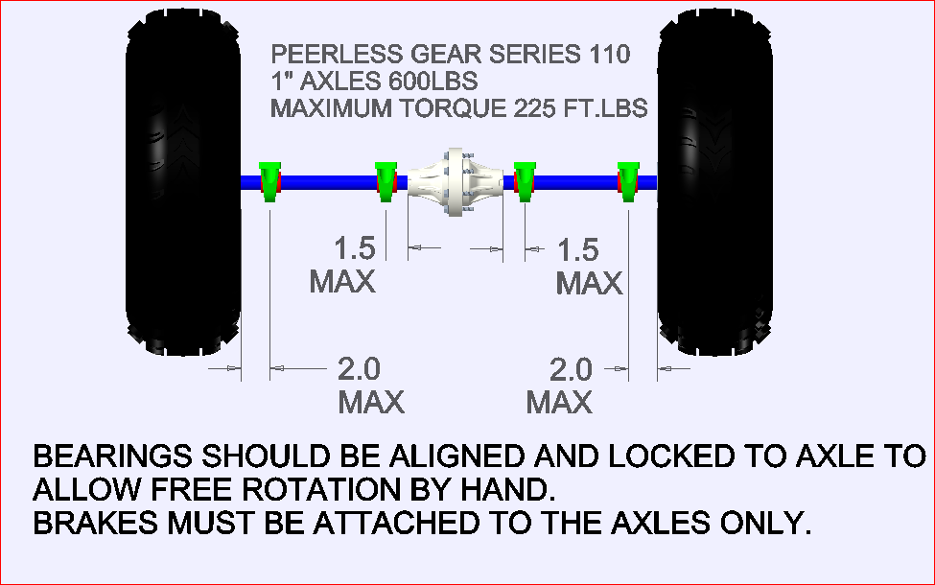
Features | Common Applications
1”-Axles. | In Plant Drives Conveyers to Mixing Machines  Utility Vehicle  Go Kart  E-Drives  Snow Blade/Blower  Pedi Cab-Bicycle
Torque capacity 225 Ft. Lbs.
Weight over axles dependent on customer supplied pillow block bearings 600 lbs.

